# Experiment No. 2: Calorimeter

Aim: To determine the calorific value of the solid propellant, Aviation turbine fuel, and BKNO3 pellets.

# Introduction

**Heat of combustion**

When reactant ‘R’ of an energetic material reacts to generate product ‘P’, heat is released (or absorbed). Since the chemical bond energy of ‘R’ is different from that of ‘P’, the energy difference between ‘R’ and ‘P’ appears as heat. The rearrangement of the molecular structure of ‘R’ changes the chemical potential. The heat of reaction at constant pressure, represented by Qp, is equal to the enthalpy change of the chemical reaction.

ΔHC = Qp (1)

where H is the enthalpy, ΔHC is the enthalpy change of the reaction, and the subscript ‘P’ indicates the condition of constant pressure. The heat produced by a reaction is expressed by HC. HC is determined by the difference between the heat of formation of the reactants, ΔHf,R and the heat of formation of the products, ΔHf,p as represented by

HC = ΔHf,R − ΔHf,p (2)

The heats of formation, ΔHf, are dependent on the chemical structures and chemical bond energies of the constituent molecules of the reactants and products. Equation (2.2) indicates that the higher the value of ΔHf,R for the reactants and the lower the value of ΔHf,p for the products, the higher the HC that will be obtained.

# Apparatus: IKA Calorimeter C 200

|  |  |
| --- | --- |
| Figure 1 Calorimeter system components | Figure 2 Schematic of decomposition vessel |

1. Basic device C 200
2. Decomposition vessel C 5010
3. Ignition adaptor
4. Gas station C 248

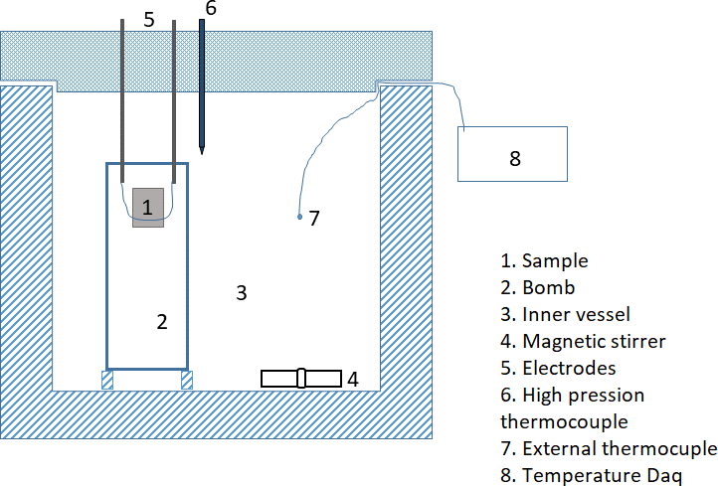

Figure 3 Detailed schematic representation of Bomb calorimeter

# Experimental Setup and Procedure

1. Complete the installation of calorimeter by connecting the plug, peripherals and the water drain.
2. Switch on the system (back of appliance).
3. Configure the system by setting the parameters in the menu i.e. GENERAL, CALIBRATION VALUES, UNIT OF MEASUREMENT, LANGAUGE, MEASURING PROCEDURE and SERVICE.
4. Appliance needs to be calibrated by entering the exact calorific value of the calibration substance used (usually benzoic acid).
5. Once appliance was calibrated, calculated C-value (calibration value) of the decomposition vessel used and enter the same in the menu of the appliance (see calculation section) , Quartz crucible (C1)=10172,Metallic crucible (C2)=10163.
6. Preparation of decomposition vessel (see Fig. 2)
   1. Unscrew the union nut and remove the cover using the handle
   2. Measure the weight of the sample using weighing balance with a least count of 0.1 mg and place it in a crucible. Note and Enter the weight directly into the calorimeter
   3. Attach a sample to the center of the ignition wire using loop
   4. Insert the crucible into the crucible holder.
   5. Using the tweezers, align the propellant sample so that it hangs inside the crucible.
   6. Place the cover onto the lower section and push down until it presses against the stop piece in the lower section. Place the union nut onto the lower section and tighten by hand.
   7. Fill the decomposition vessel using gas station C 248 to desired pressure and slide the ignition adapter onto the decomposition vessel.
7. Place the decomposition vessel into the inner vessel (between the three located bolts) of calorimeter C 200.
8. Pour two liters of tap water into the filler of tank using the measuring cup provided. Watch the level indicator.
9. Close the cover by moving it to the left out of the locking position until it slides down by itself. The decomposition vessel comes into contact with the igniters via the ignition adaptor.
10. Preparing the measurement
    1. Selecting Measurement (F2) will take you to the “prepare measurement” menu.
    2. Enter the noted weight of the propellant sample using keyboard.
    3. To access the other options press **UP/DOWN (F2)**
    4. Enter “1” to perform calibration
    5. Also check the other presetting i.e Decomposition vessel, Qexternal1, Qexternal2, Test No. Press ok (F1) to apply entries.
11. Performing the measurement: The following messages will appear during the test
    1. Storage filled-press continue (F1)
    2. Vessel safe locked- press continue (F1)
    3. Close the cover
12. The measurement process is fully automatic. The result will appear once the measuring process is complete.
13. After the measurement open the cover to automatically empty the inner vessel. Remove the decomposition vessel and the igniter adaptor. Also release the gases from decomposition vessel using the venting button under a fume hood.
14. Open the decomposition vessel and check the crucible for signs of incomplete combustion, if combustion is incomplete, discard the test result. Repeat the test.

# Tabular Column

|  |  |  |  |  |  |  |
| --- | --- | --- | --- | --- | --- | --- |
| **Test No.** | **Sample** | **Pressure in decompositi on vessel ‘bar’** | **Igniter mass**  𝐦𝐢𝐠𝐧 **‘g’** | **Calorific value of igniter**  **** 𝐡𝐜,𝐢𝐠𝐧 **‘J/g’** | **Propella nt mass**  𝐦𝐏𝐫𝐨 **‘g’** | **Calorific value of**  **propellant**  **** 𝐡𝐜,𝐏𝐫𝐨 **‘J/g’** |
| 1 | AT Fuel* |  |  |  |  |  |
| 2 | Propellant** |  |  |  |  |  |
| 3 | BKNO3*** |  |  |  |  |  |

Note: Same test is performed to measure the Calorific value of igniter.

**\*** Aviation Turbine Fuel **Composite propellant ***Boron potassium nitrate

# Calculations:

1. **Calibration:**

C= (Ho x *m* + QExternal1 + QExternal2) / T (3) Where,

C – Heat capacity (C-value) of calorimeter system (J/K) Ho- Calorific value of certified benzoic acid (known)

m – Weight of fuel sample

T – Temperature rise of water in inner vessel of measuring cell

QExternal1 – correction value for the heat energy generated by the cotton thread as ignition and QExternal2 – Correction value for the heat energy from other burning aids.

# Calorific value of calculation:

Ho =

(𝐶 ∗ ∆𝑇 − 𝑄𝑒𝑥𝑡1 − 𝑄𝑒𝑥𝑡2)

𝑚

Ho =

|  |  |  |  |  |
| --- | --- | --- | --- | --- |
|  | |  | (𝑐 ∗ ∆𝑇 − 𝑄𝑒𝑥𝑡1 − (mign ∗  hc,ign)) | |
| 𝑚 | |  |
| Where m | = | Mass of the sample | | (gm) |
| C | = | Heat capacity value of calorie meter | | (J/K) |
|  |  | Quartz crucible (C1)=10172 | | (J/K), |
|  |  | Metallic crucible (C2)=10163 | | (J/K). |
| T | = | Rise in temperature of water in the inner chamber | | (K) |
| Qext1 | = | first external burning aid (mostly cotton thread ) | | (50 J) |
| Qext2(m ign* Dh c,ing) | = | Second external burning aid | | (J) |
|  hc,ign | = | Calorific value of ignition primer | | (J/gm) |
| mign | = | Mass of ignition primer | | (gm) |

# Aviation turbine fuel

Mass of fuel =1.1846 gm

C= Quartz crucible C1 (10172 (J/K)) Qext1=50 J

Qext2=0 J

T= Find it from the readings

# Propellant

Mass of fuel =3.2664 gm

C= Quartz crucible C1 (10172 (J/K)) Qext1=0 J

Qext2=0 J

T= Find it from the readings

# BKNO3

Mass of fuel =0.7298 gm

C= Quartz crucible C1 (10172 J/K) Qext1=0 J

Qext2= m ign* h c,ing =750 J m ign=0.1116 gm

h c,ing=6720.3 J/gm

T= Find it from the readings

T Calculation

Students should note the reading from the recording and should plot the graph. Similar graph as shown in Figure *4*is obtained, T is obtained from the plotted graph

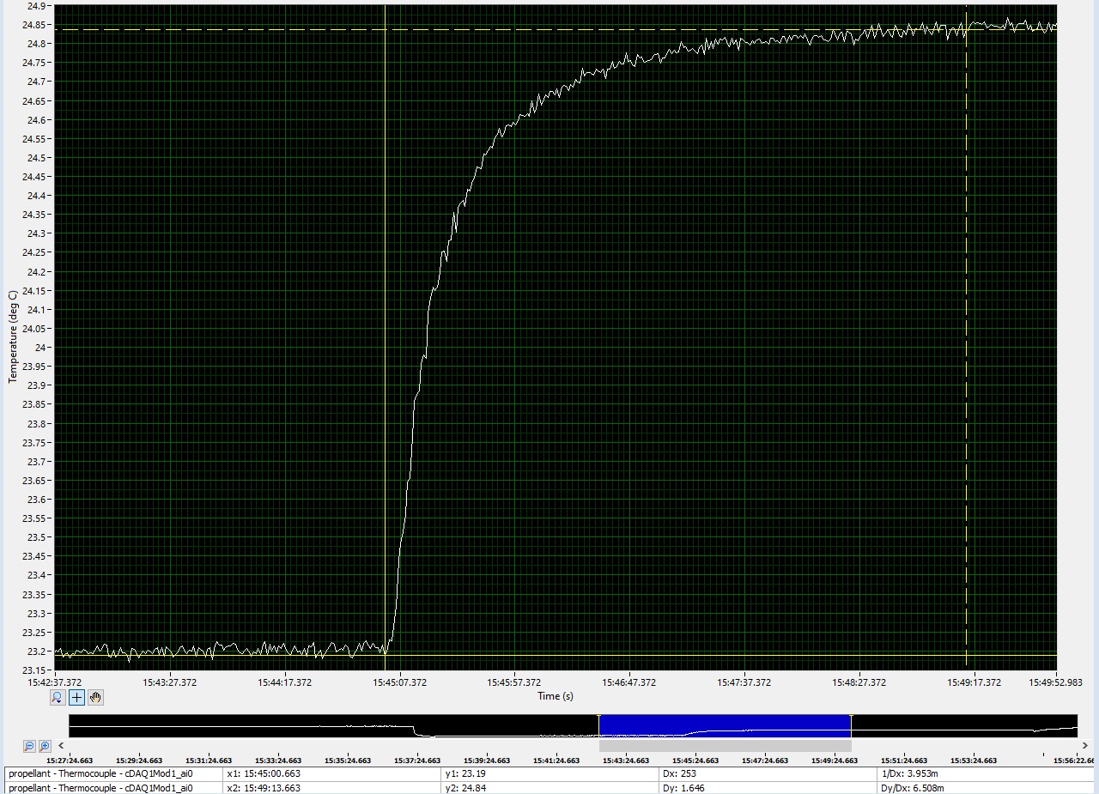



Figure 4 Evaluation of  T for propellant